

**Logistics Performance & Delay Analysis Report (BARRAQ)**

*BARRAQ Logistics – Simulated Business Report*

Report prepared by:

Shahad Abdulrahman Saleh Alshumrakh

Date:

26/05/2025

**Executive Summary**

This research analyzes the performance and delays for BARRAQ Logistics, a simulated logistics company. The goal is to detect delivery delay patterns, determine the essential causes, and suggest data-driven solutions to improve operational efficiency.   
A review of shipment data found that around 61.60% of total shipments noticed delivery delays. These delays were more common in certain regions and for specific shipment types. Notably, southern cities had the greatest delay rate (30.3%), followed closely by central cities (29.97%), showing a considerable majority of delays in these locations.

Shipment categories such as clothing and medical supplies had uncommonly high total delay days, with 609 and 595 days respectively. Furthermore, typical delivery times differed significantly among shipment types, showing variations in time management and logistical planning.   
Key findings hint to operational inefficiencies, with some shipment types taking up to three days longer than others to arrive. Geographic mapping indicated a pattern of delays in selected target cities. Furthermore, certain vehicle categories, notably motorbikes, had abnormally high delay counts, accounting for nearly 800 delay days.

Causes of delays differed in their impact. Vehicle breakdowns were indicated as the primary reason (27.14%), followed by Unclear Addresses (20.52%). These findings suggest systemic flaws in vehicle reliability and address validation methods.

**To address these issues, the report recommends:**

* Optimizing vehicle allocation strategies.
* Improve preventative maintenance programs.
* Use automated address verification tools.
* Improving communication with customers regarding expected delivery changes.
* Use real-time route optimization technologies.
* Implemented delay monitoring and alerting systems.
* Monitoring performance indicators based on shipment type, region, and vehicle.

**Optimize Vehicle Allocation**  
Reduce reliance on motorbikes for long-distance or high-priority deliveries. Assign bigger, more reliable vehicles (e.g., vans or trucks) to routes and shipment types that have previously experienced significant delay rates.

**Improve Vehicle Maintenance Protocols**  
Vehicle breakdowns account for 27.14% of delays; thus, impose stricter and more regular maintenance plans, particularly for high-usage vehicles such as motorbikes. Conduct pre-shipment vehicle checks.

**Enhance Address Verification Systems**  
To reduce delays caused by Unclear Address (20.52%), incorporate automated address validation techniques at the order stage. Train customer service employees to double-check missing or confusing address information.

**Route Optimization & Traffic Monitoring**  
Use GPS monitoring and route optimization tools to avoid crowded or high-risk routes, particularly in destinations with a large concentration of delays. Integrate real-time traffic and weather data into driving applications.

**Establish Delay Alert Systems**  
Implement a real-time alert system for shipments that are at danger of being delayed due to vehicle type, city congestion, or weather. This enables for proactive rerouting and interference.

**Segment-Based Performance Monitoring**  
Regularly review performance by shipment type, vehicle, and route. Identify bottlenecks, compare them to benchmarks, and alter logistics strategy based on historical delay data.

**Customer Communication Improvements**  
Keep customers informed of anticipated delays as early as possible by sending SMS or app alerts, especially if the delays are caused by breakdowns or address difficulties. This may reduce complaints while improving satisfaction.

**Pilot a Delivery Quality Score**  
Introduce an internal KPI scoring system that combines driver performance, delay frequency, and vehicle utilization into a single score. Assign priority responsibilities to top-performing assets.   
By acting on these insights, BARRAQ can reduce delays, boost customer satisfaction, and enhance logistical performance.

**Content Table**

1 Introduction 5

2 Business Context 5

3 Data Overview 6

4 Key Metrics Analysis 6

4.1 Shipments Overview 6

4.2 Delay Overview 7

4.3 Driver Overview 7

4.4 Customer Overview 7

5 Findings & Observations 8

6 Root Cause Analysis 9

7 Recommendations 10

8 Conclusion 10

9 Appendix 11

9.1 Appendix A - Data Sources and Structure 11

9.2 Appendix B - Data Cleaning and Preparation (Excel) 12

9.3 Appendix C - Analytical Methodology (Power BI) 13

9.4 Appendix D - DAX Measures and Calculations 15

9.5 Appendix E - Raw Data Samples 19

**1 Introduction**

This report was created for BARRAQ Logistics, a simulated logistics business, to assess shipment delivery performance and identify the causes of shipping delays. Efficient logistics operations are essential for customer satisfaction and company profitability, particularly in a competitive and time-sensitive industry.

The study simulates real-world logistics situations across Saudi Arabian cities using data like those of actual events. It analyzes critical shipping factors such as total shipment volume, delay frequency, delivery length by shipment type, and geographical patterns between origin and destination sites.

The purpose of this analysis is to:

* Understand how different shipment types perform in terms of delivery time.
* Identify the main reasons behind shipment delays.
* Visualize city-to-city delivery routes and their impact on delivery performance.
* Provide actionable recommendations that support better decision-making for logistics managers and operational leaders.

By the end of the study, stakeholders will have a comprehensive awareness of operational gaps as well as data-driven solutions for improving the reliability and efficiency of BARRAQ's shipment techniques.

**2 Business Context**

Efficient logistics performance is crucial for improving customer experience and lowering operating expenses. Timely delivery enhances customer satisfaction, develop brand trust, and encourage customer loyalty. On the other side, delays can have an impact on operations, resulting in rescheduling, additional handling efforts, and resource waste.   
  
Financially, delays frequently result in unnecessary charges such as compensation, redelivery fees, and increased fuel or labor usage. Most significantly, persistent delivery failures damaging the company's reputation. Customers frequently hold logistics providers responsible, regardless of the actual cause, which can result in a loss of market competitiveness and customer loyalty issues.

Thus, for BARRAQ Logistics, strengthening delivery performance is more than just an issue of operational efficiency, it is also a strategic requirement for sustaining brand confidence and achieving long-term business growth.

**3 Data Overview**

This analysis relies on an integrated dataset that simulates BARRAQ Logistics' operations records. The data was collected from six main files, each representing an essential part of the logistics process:

* **Main Shipments File:**  
  Contains core shipment records including Shipment ID, Customer and Driver references, Shipment and Delivery dates, origin/destination cities, vehicle types, delay status, and time metrics (delivery duration and delay duration). It also identifies delay reasons where applicable.
* **Shipment Types File:**  
  Defines each shipment type (e.g., Documents, Clothing, Electronics) and categorizes it for further analysis.
* **Drivers File:**  
  Includes details about delivery personnel, such as Driver ID, name, contact information, vehicle type, license, and employment date.
* **Customers File:**  
  Contains customer data including ID, name, phone, city, and customer classification (e.g., individual, business).
* **Delays File:**  
  Provides standardized delay reason codes, along with the party responsible for each delay (e.g., customer, company, external factors).
* **Cities File:**  
  Lists all cities involved in shipments with corresponding regions and indicates whether a BARRAQ branch is located there.

These files provide a comprehensive perspective of logistics operations and allow for multidimensional analysis of shipment behavior, delay patterns, and performance indicators across geography, shipment types, and operational roles.

**4 Key Metrics Analysis**

**4.1 Shipments Overview**

A total of 5,000 shipments were reported, with 61.60% facing delivery delays. Clothing made up 17.34% of shipments, followed by medical shipments (17.22%), food (17.02%), documents (16.54%), electronics (16.28%), and furniture (15.60%). In terms of delivery speed, the average delivery time varied little by shipment type. The longest average delivery time was 3.32 days for electronics, followed by 3.31 days for food shipments, 3.30 days for furniture, 3.25 days for clothing, 3.23 days for medical, and 3.22 days for documents. These differences, while not significant, suggest inefficiencies in logistics handling that may be addressed to improve delivery times across all categories.

**4.2 Delay Overview**

Out of the total 5,000 shipments, 3,080 were delayed, accounting for 61.60% of deliveries. Geographic examination of delays across Saudi areas reveals that the Southern region had the largest percentage of delays (30.03%), followed by the Central region (29.97%). The Eastern area had 20.84%, followed by the Northern region with 10.26%, and the Western region with 8.90%.

Delay reasons were also investigated, indicating that vehicle breakdowns were the most frequent cause of delay, accounting for 27.14% of all delays, followed by unclear addresses (20.52%). Other factors were weather (10.32%) and security checks (3.62%). Shipments with no delays accounted for 38.40% of the total.

The **yearly trend of delay days** indicated that the highest number of one-day delays occurred in 2024 (696 days), followed by 2023 (416 days) and 2025 (245 days). For two-day delays, the counts were 522 in 2024, 349 in 2023, and 155 in 2025. Three-day delays followed a similar pattern, with 246 in 2024, 170 in 2023, and 100 in 2025. Four-day delays showed 78 in 2024, 47 in 2023, and 37 in 2025. Longer delays of 5 to 6 days were rare, with counts below 10 in all years.

Since **vehicle breakdowns** were the leading cause of delays, further analysis was conducted to identify the most problematic vehicle types. **Motorbikes** topped the list with 769 total delay days, followed by **small trucks** with 781, **vans** with 757, and **large trucks** with 746 delay days.

**4.3 Driver Overview**

The company currently employs a total of 40 drivers. Among them, three have been recognized as the top-performing drivers, based on their **Timeliness Score**, which serves as a key indicator of reliability — the higher the score, the better the driver’s performance. Conversely, lower scores reflect poor performance. As part of the evaluation, each driver’s total number of shipments was compared against the number of days they were delayed. This helped identify drivers with underperformance, which was primarily attributed to low Timeliness Scores.

Notably, **Naif Al-Ahmadi** has been nominated as the best driver for the past two consecutive years, due to his exceptional performance and consistently high Timeliness Score.

**4.4 Customer Overview**

This report provides a comprehensive overview of customer-related shipment performance based on delay frequency and address accuracy.

* **Total Customers**: The analysis includes data from **500 customers**.
* **Best Customer**: Based on key performance indicators such as shipment volume and reliability, **Salem Alsobaie** was identified as the best-performing customer.
* **Delay Analysis**: Salem Alsobaie also appears as the customer with the **highest delay count**, recording **38 shipment delays**, followed by Omar Almalki and Bander Alshihri with 29 and 26 delays respectively.
* **Top Customers**: The dashboard highlights the top 5 customers by shipment volume. Among them:

1. Salem Alsobaie tops the list with **55 shipments** from Buraidah.
2. Omar Almalki follows with **49 shipments** from Taif.
3. Other top customers include Badr Alharbi, Bander Alshihri, and Saif Albogmi, all from key cities like Dammam and Abha.

* **Geographical Activity**: The most active cities in terms of shipment volume include **Mecca (347 shipments)**, **Medina (322)**, and **Tabuk (331)**, indicating regional shipment concentration.
* **Address-Related Delays**: An additional analysis of delays caused by address issues shows that **Omar Almalki** and **Salem Alsobaie** also lead in this category, indicating a possible link between their delay rates and address data quality.

**5 Findings & Observations**

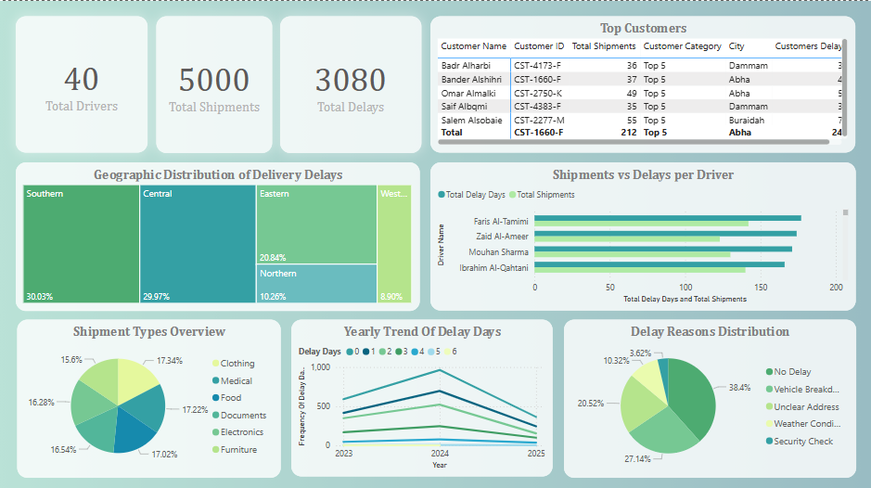

The Figure 5.1 Shows the analytical dashboard for BARRAQ.

The data revealed that out of 5,000 total shipments, **3,080 shipments were delayed,** accounting for **61.60%** of the total volume. In terms of **geographic distribution,** delays were **most prevalent in the Southern region** (30.03%), followed closely by the **Central region** (29.97%), then the **Eastern region** (20.84%), the **Northern region** (10.26%), and finally the **Western region** (8.90%). This regional breakdown indicates operational inconsistencies that may be linked to infrastructure, branch performance, or routing inefficiencies.

When examining **delay reasons, vehicle malfunction** emerged as the most common cause, responsible for **27.14%** of all delays. This was followed by **unclear addresses (20.52%), weather conditions (10.32%),** and **security checks (3.62%).** Conversely, **non-delayed shipments represented only 38.40%,** highlighting a significant performance issue.

The **yearly trend of delay durations** further emphasized 2024 as the year with the **highest frequency of one-day delays (696 shipments),** followed by 2023 (416) and 2025 (245). Two-day delays also peaked in 2024 (522 shipments), while longer delays of **5–6 days** were rare, with fewer than 10 recorded cases each year, indicating most delays are short but frequent.

Given the high frequency of delays due to vehicle breakdowns, an additional analysis was conducted to identify the **most failure-prone vehicle types**. The **motorbike** had the highest number of breakdowns (769 cases), followed by **small trucks (781), vans (757),** and **large trucks (746),** underscoring the need for a vehicle maintenance and fleet reliability strategy.

Lastly, the analysis highlighted **disparities in delivery time** based on both **shipment type** and **destination city. Electronics** required the longest average delivery time (approx. **3.32 days**), followed by **food (3.31 days)** and **furniture (3.30 days).** In contrast, **medications (3.22 days)** and **documents (3.23 days)** were delivered faster, likely due to their urgency. Additionally, some cities showed longer average delivery durations than others, possibly linked to their distance, infrastructure, or logistics planning. These findings suggest a need for **targeted improvements in city-specific delivery logistics** and better **route optimization** to ensure equitable service levels across all regions.

**6 Root Cause Analysis**

The root cause analysis reveals that delivery delays at BARRAQ Logistics are primarily driven by internal operational issues rather than external uncontrollable factors. The most significant root cause is vehicle malfunction, responsible for over 27% of delayed shipments, indicating a gap in preventive maintenance and fleet reliability. This is further confirmed by the high delay frequency in vehicle types like motorbikes and small trucks, suggesting that older or overused vehicles are not being rotated or serviced effectively.

Another critical root cause is inaccurate or unclear delivery addresses, accounting for 20.52% of delays. This points to weaknesses in customer input validation and the absence of automated address verification processes, which causes drivers to lose time attempting to locate destinations manually.

Geographic delay patterns show that Southern and Central regions suffer from the highest delay rates, suggesting either a shortage in local resources (such as drivers or branches), inefficient routing strategies, or logistical congestion unique to those areas.

Furthermore, while external factors like weather conditions and security checks contribute to delays, their relatively low percentages (10.32% and 3.62%, respectively) confirm that the core problems are systemic and can be addressed through better internal planning, technology integration, and operational discipline.

In short, the data points clearly to preventable internal inefficiencies—primarily vehicle maintenance, address validation, and uneven resource distribution—as the true root causes behind the delivery performance issues.

**7 Recommendations**

To address the high delay rate and operational inefficiencies revealed in the data, the following actions are recommended:

1. **Implement a Fleet Maintenance Program**: Given that vehicle malfunctions are the top cause of delays (27.14%), a proactive and scheduled maintenance system must be enforced, especially for small trucks, vans, and motorbikes, which show the highest breakdown frequencies.
2. **Enhance Address Validation Systems**: With 20.52% of delays caused by unclear addresses, BARRAQ should deploy digital address verification tools, require more detailed input from customers, and consider adding real-time communication with drivers to resolve location issues faster.
3. **Optimize Route Planning per Region**: The Southern and Central regions have the highest delay rates. Investing in smarter route planning, increasing fleet coverage, or strengthening branch operations in these areas can help minimize regional delivery inefficiencies.
4. **Review and Rebalance Shipment Allocation**: Shipment types like electronics and food have longer delivery times. BARRAQ should reassess how these shipments are prioritized and possibly assign faster or more reliable vehicles to these categories.
5. **Establish a Driver Performance Program**: Introduce a scoring system based on delivery timelines and delay rates and recognize consistently high-performing drivers. This motivates accountability and improves delivery reliability.
6. **Weather and Security Contingency Plans**: Although smaller in percentage, weather conditions and security checks still disrupt operations. Having predefined alternative routes or protocols can reduce their impact.
7. **Leverage Predictive Analytics**: Use historical data trends to predict potential delays based on shipment type, region, and time of year—enabling BARRAQ to act preventively rather than reactively.

**8 Conclusion**

The data-driven study of BARRAQ Logistics' delivery performance reveals a critical need for operational adjustments to reduce shipping delays and increase customer satisfaction rates. Over 61% of shipments arrive late, owing to internal difficulties such as vehicle failures and incorrect addresses, putting the company's image at risk as well as increasing operating expenses. Delay patterns differ by area and cargo type, stressing the need for more specialized strategies and smarter logistics planning.   
Addressing these core causes through preventative fleet maintenance, enhanced address verification systems, and efficient resource allocation would not only minimize delays but also increase BARRAQ's market position and customer trust. Finally, these insights give a clear path for strategic action and ongoing performance monitoring to ensure long-term success in a competitive logistics environment.

**9 Appendix**

**9.1 Appendix A - Data Sources and Structure**

The dataset used in this analysis is entirely fictional and was generated and exported through ChatGPT. It was then cleaned, modified, and enhanced in Microsoft Excel to align with the context of a hypothetical logistics company named **Barraq**.

Several columns were added or adjusted to better represent realistic operational scenarios within a shipping and delivery business. These enhancements included delivery times, delay reasons, shipment types, and driver-related information.

After the initial data preparation in Excel, the structured dataset was imported into **Power BI** for modeling and dashboard creation.

All tables in the model are connected to the central **Shipments** fact table, which serves as the core of the data model. Each relationship is structured as a one-to-many (1:*), where the referenced dimension table has a unique key and the **Shipments** table contains the foreign key.

* **Customers → Shipments**: A one-to-many relationship based on Customer ID. Each customer can have multiple shipments associated with them.
* **Cities → Shipments**: A one-to-many relationship based on City. A city can be assigned to multiple shipments through the Origin City field in the **Shipments** table.
* **Delays → Shipments**: A one-to-many relationship using Delay Reason. Each delay reason can be associated with multiple delayed shipments.
* **Drivers → Shipments**: A one-to-many relationship via Driver ID. A single driver can handle multiple shipments across the dataset.
* **Shipment Types → Shipments**: A one-to-many relationship through Shipment Type. Each shipment type can categorize numerous shipments under the same classification.

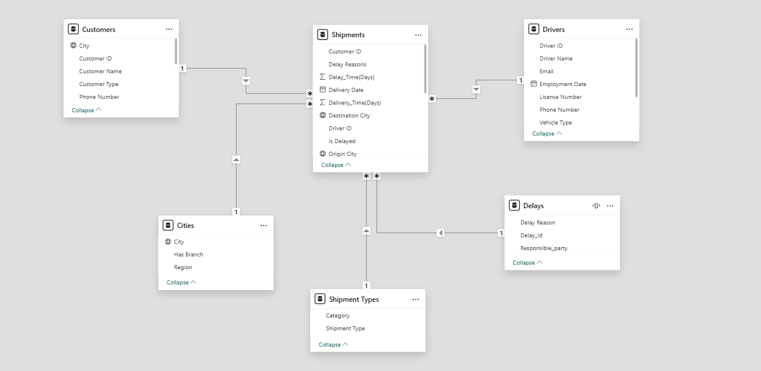

Figure 9.1.1 BARRAQ model view.

The relationships in Fig 9.1.1 were defined within **Power BI** and are essential for enabling cross-filtering and analytical slicing between the dimensions and the main shipment records. The structure allows for dynamic insights across operational, geographic, and performance dimensions of the data.

**9.2 Appendix B - Data Cleaning and Preparation (Excel)**

The initial dataset underwent a thorough cleaning and preprocessing phase using **Microsoft Excel** to ensure data accuracy and consistency before being imported into Power BI.

• **Blank Spaces, Formatting, and Data Types**:  
Blank spaces in key fields were identified and removed to avoid errors in relationships and aggregations. Text fields that originally represented numeric values were converted into proper numerical formats. Date fields were standardized into consistent date formats, and text casing and hidden whitespaces were cleaned to ensure consistency across the dataset.

• **Date Corrections**:  
Some entries contained incorrect or reversed date values, such as a **delivery date** appearing earlier than the **shipment issue date**. These records were flagged and corrected to reflect logical and realistic shipment timelines.

• **Column Additions**:  
Several new calculated columns were added to enhance the analytical capabilities of the dataset:

1. **Delivery_Time(Days)** – Calculates the total number of days between the shipment issue date and the delivery date.
2. **Delay_Time(Days)** – Measures the duration of delivery delays in days.
3. **Delivery Year** – Extracts the year from the delivery date to enable year-based trend analysis.
4. **Delivery Cost** – A field representing the cost associated with delivering each shipment.
5. **Shipping Price** – Indicates the total price charged for shipping, which can be used in revenue analysis.

These cleaning steps were critical to ensure that the data used in the analysis was reliable and reflective of actual operational patterns.

**9.3 Appendix C - Analytical Methodology (Power BI)**

After data preparation, Power BI was utilized for data modeling, dynamic visualization, and in-depth analysis. The following methodological steps were applied:

* **Data Import and Transformation**: Cleaned Excel data was imported into Power BI using Power Query. Additional transformations were applied, such as data type conversions, removal of unnecessary columns, and filtering out invalid records.
* **Data Modeling and Relationships**: All tables were connected through a centralized data model. Relationships were defined using appropriate keys (e.g., Driver ID, Customer ID, Shipment Type), following a star schema design where the **Shipments** table served as the fact table.
* **Custom Calculated Columns**: Multiple calculated columns were created to enrich the analysis, such as:
  + Delivery_Time (Days)
  + Delay_Time (Days)
  + Year
  + Paid Amount
* **Interactive Dashboard Design**: A user-friendly, visually structured dashboard was built, targeting both executive-level summaries and operational deep-dives. Instead of a single view, four detailed reports were developed as demonstrated in **Figures 9.3.1 to 9.3.4**, each focusing on a specific operational dimension:

1. **Shipment Analysis Report** – Analyzed shipment categories by volume and delay percentage (e.g., food, medical, electronics).
2. **Delay Report** – Mapped out delay causes and regional delay distribution to uncover operational bottlenecks.
3. **Driver Performance Report** – Tracked shipment count per driver, delay days, and identified top and underperforming drivers.
4. **Customer Satisfaction Analysis Report** – Analyzed customer shipment volume, delay incidents, customer categories, and identified customers most affected by delivery issues.

صورة تحتوي على نص, لقطة شاشة, رسم بياني, رقم

تم إنشاء الوصف تلقائياً

Figure 9.3.1 Displays a comprehensive shipment report.

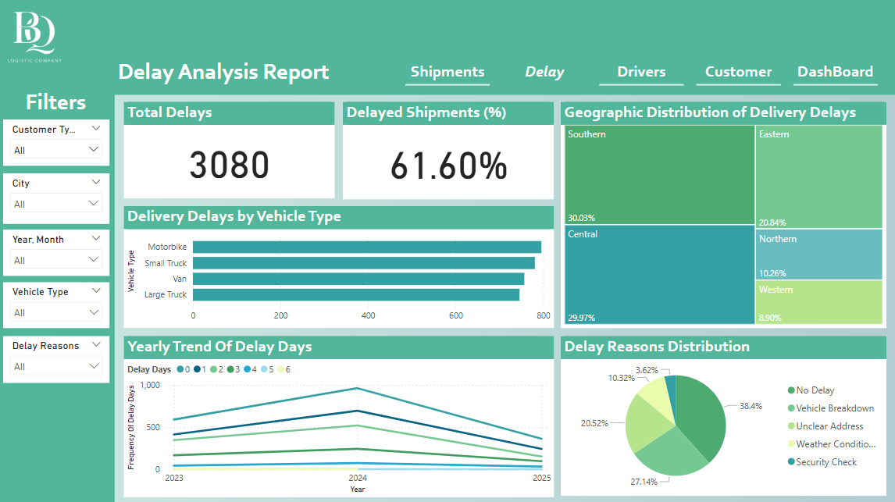

Figure 9.3.2 shows the delay report.

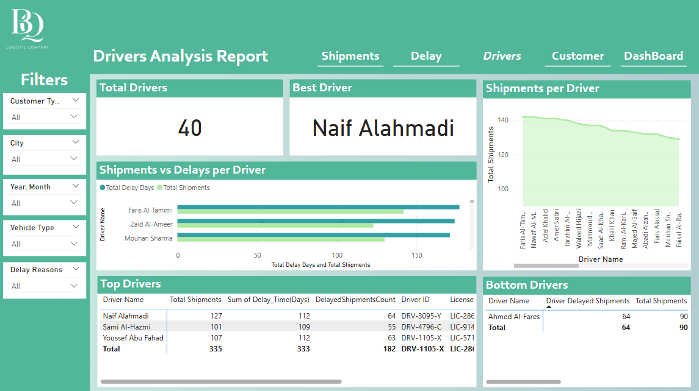

Figure 9.3.3 Driver's performance report.

**صورة تحتوي على نص, لقطة شاشة, رسم بياني, الخط

تم إنشاء الوصف تلقائياً**

The Figure 9.3.4 presents a report analyzing customer satisfaction.

* **Filter & Slicer Integration**: Dynamic slicers were added for filtering by **Customer Type**, **Year**, **Vehicle Type, City** and **Delay Reason** to allow flexible, on-demand data exploration.
* **Cards and Conditional Formatting**: Key performance indicators were highlighted using cards with conditional formatting to quickly signal areas of concern or outstanding performance.

**9.4 Appendix D - DAX Measures and Calculations**

**Shipments Measures:**

* **Avg Delivery Duration**  
  Calculates the average delivery duration in days for all shipments.

Avg Delivery Duration = AVERAGE('Shipments'[Delivery_Time(Days)])

* **Delayed Shipments %**  
  Calculates the percentage of delayed shipments out of total shipments.

Delayed Shipments % = DIVIDE(

CALCULATE(

COUNTROWS('Shipments'),

FILTER('Shipments', 'Shipments'[Is Delayed] = TRUE())

),

COUNTROWS('Shipments'),

0

)

* **DelayedShipmentsCount**  
  Counts the number of shipments that were delayed.

DelayedShipmentsCount =

CALCULATE (

COUNTROWS('Shipments'),

'Shipments'[Is Delayed] = TRUE())

* **Total Shipments**  
  Calculates the total number of shipments.

Total Shipments = COUNTROWS('Shipments')

**Customers Measures:**

* **Best Customer Max Shipments**  
  Returns the name(s) of the customer(s) with the highest number of shipments.

Best Customer Max Shipments =

VAR ShipmentsCount =

SUMMARIZE('Shipments',

'Customers'[Customer Name],

"Shipments", COUNTROWS('Shipments')

)

VAR MaxShipments =

MAXX(ShipmentsCount, [Shipments])

VAR BestCustomer =

SELECTCOLUMNS(

FILTER(ShipmentsCount, [Shipments] = MaxShipments),

"Customer", [Customer Name]

)

RETURN

CONCATENATEX(BestCustomer, [Customer], ", ")

* **Customer Rank by Delays**  
  Ranks customers based on the number of delayed shipments, from highest to lowest.

Customer Rank by Delays =

RANKX(

ALL('Customers'[Customer Name]),

[Total Delays per Customer],

,

DESC

)

* **Customer Rank by Shipments**  
  Ranks customers based on the total number of shipments, from highest to lowest.

Customer Rank by Shipments =

RANKX(

ALL('Customers'[Customer Name]),

[Total Shipments per Customer],

,

DESC

)

* **Top 5 Customers Label**  
  Labels customers as 'Top 5' if they are among the top 5 in terms of total shipments.

Top 5 Customers Label =

IF(

[Customer Rank by Shipments] <= 5, "Top 5",

BLANK()

)

* **Total Delays per Customer**  
  Counts the number of delayed shipments per customer.

Total Delays per Customer =

CALCULATE (

COUNTROWS('Shipments'),

'Shipments'[Is Delayed] = TRUE ()

)

* **Total Shipments per Customer**  
  Calculates the total number of shipments for each customer.

Total Shipments per Customer =

COUNTROWS('Shipments')

**Drivers Measures:**

* **Best Driver by Timeline Score**  
  Returns the driver(s) with the best timeline score (lowest delay ratio), considering only those with more than 100 shipments.

Best Driver by Timeline Score =

VAR DriverStats =

ADDCOLUMNS(

SUMMARIZE('Shipments', 'Drivers'[Driver Name]),

"TotalShipments", CALCULATE(COUNTROWS('Shipments')), "TotalDelayDays", Shipments[DelayedShipmentsCount])

VAR WithRate =

ADDCOLUMNS(

DriverStats,

"Timeline Score", DIVIDE([TotalDelayDays],

[TotalShipments], 0)

)

VAR QualifiedDrivers =

FILTER(WithRate, [TotalShipments] > 100)

VAR MinRate =

MINX(QualifiedDrivers, [Timeline Score])

VAR BestDriver =

SELECTCOLUMNS(

FILTER(QualifiedDrivers, [Timeline Score]

MinRate),

"Driver", 'Drivers'[Driver Name]

)

RETURN

CONCATENATEX(BestDriver, [Driver], ", ")

* **DriverCategory**  
  Categorizes drivers as 'Best Driver', 'Worst Driver', or 'Neutral' based on their shipment and delay counts.

DriverCategory =

SWITCH(

TRUE(),

[Total Shipments] > 100 && [DelayedShipmentsCount] <

65, "Best Driver",

[Total Shipments] < 100 && [DelayedShipmentsCount] >

60, "Worst Driver",

"Neutral"

)

* **Timeline Score**  
  Calculates the delay ratio by dividing the sum of delays by the total number of shipments.

Timeline Score =

VAR TotalDelaysDays = CALCULATE(SUM('Shipments'[Is Delayed]))

VAR TotalShipments = CALCULATE(COUNTROWS('Shipments'))

RETURN DIVIDE(TotalDelaysDays, TotalShipments, 0)

**9.5 Appendix E - Raw Data Samples**

In table 9.5.1 are the samples of raw data from Power BI to illustrate the structure of the original datasets.

| **Field Name** | **Sample Value** | **Data Type** |
| --- | --- | --- |
| Shipment ID | SH-O15941-E | Text |
| Customer ID | CST-3831-Z | Text |
| Driver ID | DRV-6256-G | Text |
| Shipment Type | Medical | Text |
| Origin City | Abha | Text |
| Destination City | Khobar | Text |
| Paid Amount | 30 | Whole Number |
| Year | 2024 | Whole Number |
| Vehicle Type | Small Truck | Text |
| Shipment Date | 16/01/2024 | Date |
| Delivery Date | 20/01/2024 | Date |
| Is Delayed | TRUE | Boolean |
| Delivery_Time (Days) | 4 | Whole Number |
| Delay Days | 2 | Whole Number |
| Delay Reasons | Unclear Address | Text |
| Customer Name | Omar Alshihri | Text |
| Phone Number (Customer) | 4463819064 | Number (Text) |
| Customer City | Mecca | Text |
| Customer Type | Business | Text |
| Driver Name | Waleed Hijazi | Text |
| Phone Number (Driver) | (188)989-2155x09716 | Text |
| Email (Driver) | [hbird@gmail.com](mailto:hbird@gmail.com) | Text |
| Driver Vehicle Type | Large Truck | Text |
| License Number | LIC-27102 | Text |
| Employment Date | 2023-02-05 | Date |
| Delay ID | UA | Text |
| Responsible Party | Customer | Text |
| Shipment Category | Documents | Text |
| Category Type | Paperwork | Text |
| City | Riyadh | Text |
| Region | Northern | Text |
| Has Branch | TRUE | Boolean |

Table 9.5.1 Raw data sample